

Information pack

Torres & Cape Hospital and Health Board – 2023

Contents

Summary 3

Key dates and timeline 3

Further information 3

How to apply 3

Overview 3

Application process 4

Member applicants 4

Probity checks 5

Personal information 6

Background 6

Queensland Health 6

Hospital and Health Services 7

Hospital and Health Boards 9

Role of Boards 9

Membership 9

Terms of appointment 10

Role and accountabilities 11

Overview 11

Board members 11

Board fees and allowances 11

Public Sector Employees 12

Hospital and Health Service Profile 13

Torres and Cape HHS 13

# Summary

This Information pack provides you with the information you need to complete an application for the Torres and Cape HHB member position.

The application process will be facilitated by Eden Ritchie Recruitment.

## Key dates and timeline

**Closing date for applications is midnight, Friday 1 September 2023.**

The steps involved in progressing a government appointment process can take some time. For this reason there is a significant period of time which elapses between applying for a position and notification of the outcome.

| **2023 Torres and Cape Hospital and Health Boards Appointment timeline** | |
| --- | --- |
| Application period | 15 August – 1 September 2023 |
| Applicant review period | September 2023 |
| Interviews | September 2023 |
| Endorsement of nominees and government approval process pursuant to the *Hospital and Health Boards Act 2011* | October 2023 to early February 2024 |
| Gazette Notice and commencement of Appointments | Early 2024 |

## Further information

If you require more information that is not contained in this information pack, please contact Justine at Eden Ritchie Recruitment for a confidential discussion.

* Justine Eden, Director, email: [justine@edenritchie.com.au](mailto:justine@edenritchie.com.au) phone: 0412 156 930.

# How to apply

## Overview

Eden Ritchie Recruitment will facilitate this application process. Prior to submitting your application, please ensure that all required documents are attached, and forms are fully completed and meet the stated requirements.

Applicants will be kept informed of the progress of their application at regular intervals. However, prospective applicants should note that the outcome of the recruitment process cannot be confirmed until the appointment of the successful applicants is published in the *Queensland Government Gazette* which is anticipated to occur in early 2024.

Where possible, applicants who have not progressed to interview will be advised at an earlier stage of the recruitment process.

## Application process

For instructions on how to submit your application, please visit the application website at:

[www.edenritchie.com.au/hhb-appointment/](http://www.edenritchie.com.au/hhb-appointment/)

Applicants are required to provide the following documentation:

* Curriculum Vitae (CV) – no more than two (2) pages in length[1]
* Completion of an online application form in addition to other personal and professional information.
* **To complete this online application form, you will also be required to attach a Personal Statement comprising a personal statement of no more than two (2) pages addressing member criteria outlined below.**

Initial shortlisting will be undertaken following the close of the application period. Applicants selected for progression will be contacted to provide additional documentation to support a range of supplementary probity checks required for Governor in Council consideration.

Please note that a request for probity documentation does not necessarily indicate that your nomination will be successful.

### Member applicants

Personal statements for member positions must not exceed two (2) pages and should address the following criteria:

the reason for your interest in being a member of the Torres and Cape HHB

how you think you will be able to add value to the Torres and Cape HHB being able to perform its role through your skills, knowledge and experience

the boards of which you have previously been a member (including your role on the board and any board committee responsibilities) *[not required if listed in your CV]*

your qualifications and professional registrations (including professional registration numbers if applicable) *[not required if listed in your CV]*

your membership of professional associations *[not required if listed in your CV]*

demonstrated ability to analyse, critically assess and drive performance (financial or non-financial) within a health sector, other public sector, community sector or other associated industry organisation

demonstrated ability to constructively build and manage stakeholder relationships

capacity to relate, and appropriately respond to, the interests of consumers of health services

demonstrated level of superior interpersonal, verbal and written communication

your CV and cover letter should also demonstrate evidence of the following required personal attributes:

* + - Leadership: leadership skills including the ability to appropriately represent the organisation, set organisational culture and take responsibility for decisions
    - Thinking and acting strategically: the capacity to understand and contribute to the strategic direction of the HHS, in line with broader whole of government and Departmental strategies, and awareness of the impact on broader systems. The ability to critically analyse complex and detailed information, easily distil key issues and develop innovative approaches and solutions to problems
    - Personal integrity: exemplifies personal integrity and has a strongly held commitment to openness, honesty, inclusiveness and high standards
    - Political astuteness: the capacity to understand and work effectively with diverse interest groups and power bases within organisations and the wider community, and the dynamic between them
    - Commercial acumen: the capacity to think quickly and make sound judgments in a complex commercial context
    - Self-management: the capacity to self-manage and display resilience in a range of complex and demanding situations
    - Contributor and team player: the ability to work as part of a team and demonstrate the passion and time to make a genuine and active contribution.

Details of two (2) professional referees (name, contact number, email and relationship, including years known), preferably a chair of a board to whom you have reported or your recent direct manager. *[Alternative referees may be required - for example, if the referee is part of this decision‑making process]*

**Please note that referees will only be contacted where applicants are shortlisted for progression to the Minister for Health, Mental Health and Ambulance Services and Minister for Women.**

## Probity checks

Probity documentation will be requested if your application is selected for progression. You will be required to complete:

* Personal particulars form
* Criminal history check form

As statutory appointees, the Queensland Cabinet Handbook requires a range of probity checks to be undertaken on potential Board members which include:

* a review of any conflicts of interest
* a national criminal history search
* an Interpol search
* searches of the Australian Securities and Investments Commission’s banned and disqualified register and bankruptcy index
* a review of the Queensland government lobbyist register, and other internet‑based searches

Probity checks will be initiated on a confidential basis.

Applicants should note that disclosure of conflicts of interest or convictions for an offence may not precludeprogression to appointment as each instance will be considered on a case by case basis.

Referee checks may also be undertaken by the project team from Eden Ritchie Recruitment for all nominees selected for progression. Please note your referees will not be contacted without your prior consent.

## Personal information

Personal information collected about applicants will be collated to assess their suitability for appointment to the Board.

Personal information collected by the Department of Health is handled in accordance with the *Information Privacy Act 2009*. The personal information provided by you will be securely stored and made available only to appropriately authorised officers. Personal information recorded on this form will not be disclosed to other parties without your consent, unless required by law.

Personal information may be disclosed as part of the recruitment process, for example, in contacting referees or obtaining certification of public sector employee nominees.

This means information will be treated confidentially and may be used in a de-identified format to:

* meet whole-of-Government reporting requirements
* support the monitoring of the diversity of appointments to statutory and other bodies
* allow accurate reporting on the profile of the State’s public sector entities’ board and committee memberships.

Names of successful applicants appointed by the Governor in Council will be published in the *Queensland Government Gazette* in accordance with the requirements of the Act. The names of these appointees will also be:

* made available on the Queensland Health and relevant HHS websites
* added to the Register of Appointees,[2] which provides information about all Government bodies.

# Background

## Queensland Health

The Queensland Government delivers free universal health care to five million Queenslanders through Queensland Health.

Health is a top priority for the Queensland Government. In the 2022/23 financial year, the Queensland Government is investing a record of $23.6 billion into healthcare with a focus on investing in new hospitals and facilities, hiring additional workforce, redesigning models of care, strengthening mental health and adopting new technology.

Queensland Health is made up of the Department of Health (Department) and 16 independent Hospital and Health Services (HHSs). The Boards are responsible for managing their respective HHS and its delivery of healthcare in their region. The Boards are accountable to the Minister for Health, Mental Health and Ambulance Services and Minister for Women (the Minister).

Board members are key leaders in their local communities with important responsibilities overseeing the efficient, effective and sustainable delivery of health services and assisting their HHS plan for the future.

The Department’s role includes, but is not limited to:

* providing strategic leadership and direction for health through the development and administration of policies and legislation
* developing state‑wide plans for health services, workforce and major capital investment
* managing major capital works for public sector health service facilities
* purchasing health service delivery
* supporting and monitoring the quality of health care service delivery
* delivering specialised health services, providing ambulance, health information and communication technology and state‑wide health support services.

Queensland Health’s 10 Year Vision*:* [*My Health, Queensland’s Future: Advancing Health 2026*](https://www.health.qld.gov.au/system-governance/strategic-direction/plans/vision-strategy/) provides a strong platform to enable the public health system to focus its decision-making and policy development over the next decade.

Boards and HHSs directly support the [Queensland Government objectives for the community](https://www.qld.gov.au/__data/assets/pdf_file/0029/146477/objectives-for-the-community.pdf) such as:

* Supporting jobs
* Backing our frontline services
* Keeping Queenslanders safe

## Hospital and Health Services

There are 16 HHSs, each comprising a network of public hospitals and health services within a geographic or functional area. HHSs are responsible for the delivery of public health services in their geographical area. The only exception is Children’s Health Queensland HHS which has a state‑wide responsibility and offers a range of specialist paediatric services across Queensland.

The *Hospital and Health Boards Act 2011* (the Act) and the associated *Hospital and Health Boards Regulation 2012* establish HHSs as independent statutory bodies and set out the functions and powers of HHSs and their relationship with the Department. The main functions of a HHS is to deliver hospital and other health services, teaching, research and other services stated in each HHSs service agreement with the Department. The other functions of a HHS is outlined in section 19 of the Act.

A short profile for Torres and Cape HHS is provided at Appendix 1. Further information about each of the other HHSs can be found [here](https://www.health.qld.gov.au/system-governance/health-system/hhs/about).

[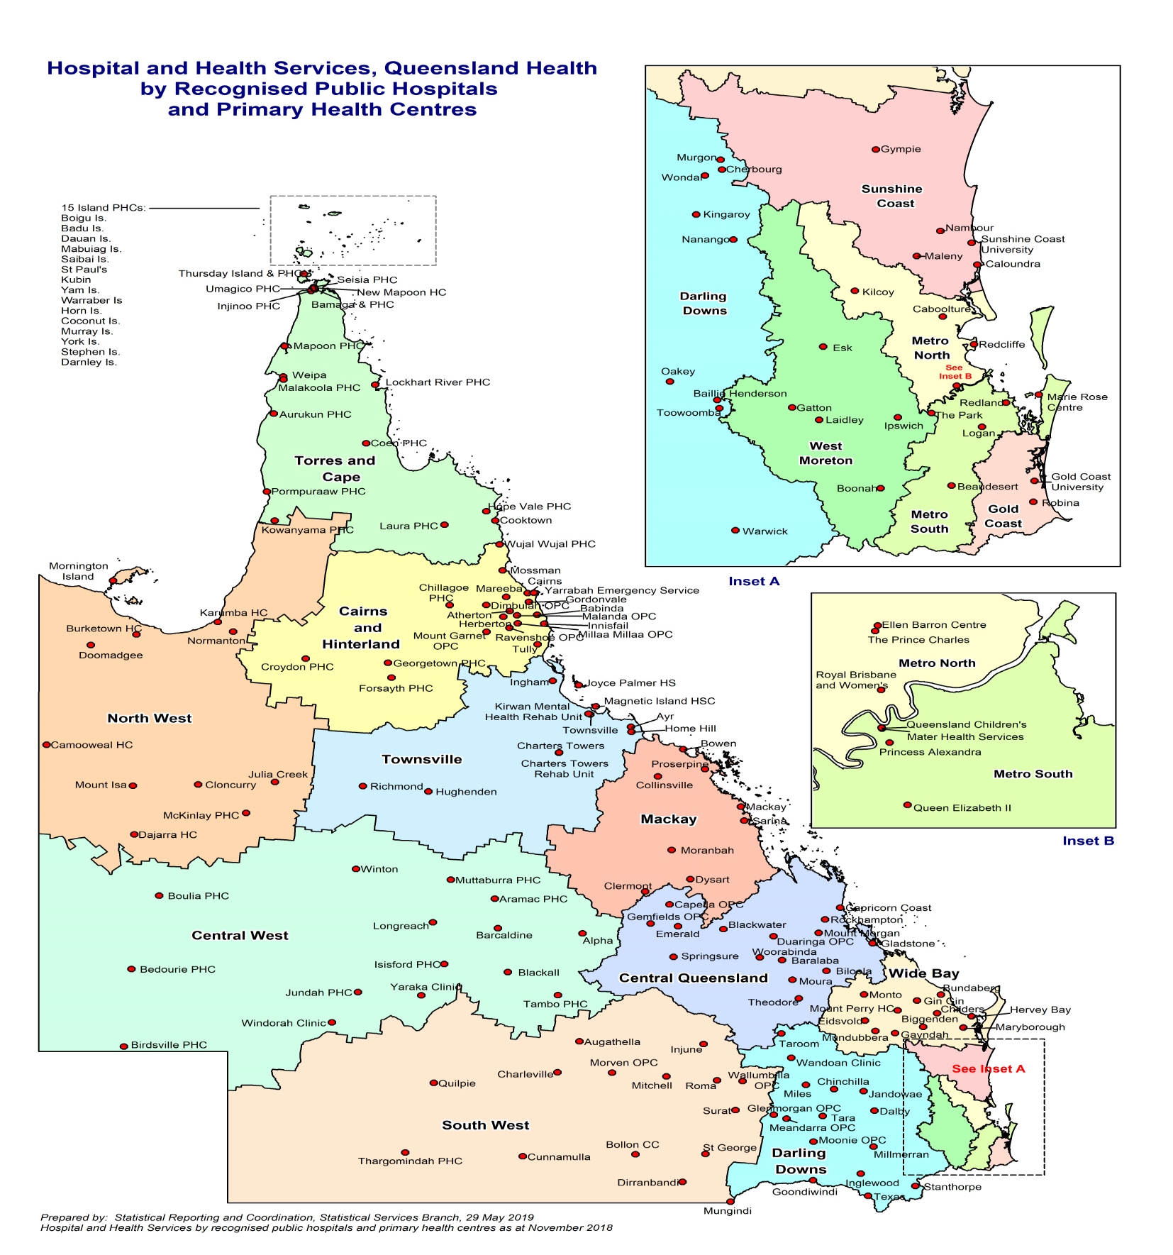](https://www.health.qld.gov.au/maps)

# Hospital and Health Boards

## Role of Boards

Boards manage the relevant HHS for which each Board is established. The Board is accountable to the Minister for the HHSs performance. HHSs are required to comply with whole-of-Government governance frameworks, including planning, reporting and financial accountability requirements.

Boards are responsible for ensuring their HHS performs its functions under section 19 of the Act. This includes the obligation to develop statements of priorities and strategic plans for the corporate governance of the HHS, and to monitor compliance with those statements and plans.

Boards are accountable for their HHSs performance and for establishing and maintaining effective systems to ensure that hospital services, other health services, teaching, research and other services stated in its service agreement are met.

Each HHS has an [individual service agreement](https://www.health.qld.gov.au/system-governance/health-system/managing/agreements-deeds) with the Department that identifies the core services to be provided, the standard to which they are to be provided and the funding available to deliver those services.

Boards are responsible for ensuring:

* efficient, effective and sustainable delivery of health services
* financial accountability
* local reporting and performance management, including risk management
* legal and statutory compliance
* local strategic direction and planning for the HHS
* client-focussed delivery of services
* ethical behaviour.

The Board also has responsibilities regarding the appointment of the Chief Executive of each HHS.

## Membership

Appointments to the Boards are made by the Governor in Council on the recommendation of the Minister. In conjunction with the HHSs Chief Executive, appointed by and accountable to the Board, Boards are directly accountable to the Minister for the performance of their HHS.

Under section 23 of the Act, Boards must comprise five or more members, at least one or more of the members must be Aboriginal persons and/or Torres Strait Islander persons and one or more of the members must be clinicians.[3]

The Act does not specify the maximum size of a Board. Requirements may vary depending on the collective experience and expertise of existing members and the needs of the particular HHS. Membership currently ranges between 8 and 11 members.

## Terms of appointment

In accordance with section 26 of the Act, a member is appointed for a term of not more than four years. Appointments are made on a part‑time basis and appointment terms are generally between one to four years. There is no limit to the number of times a member may be reappointed.

# Role and accountabilities

## Overview

Board members are key leaders in their local communities. They fulfil important internal governance obligations in relation to the oversight of HHS operations and will often represent the HHS at meetings, events and community activities. These additional activities may occur outside standard business hours.

The geographical areas of HHSs are large and additional time commitment may be required by Board members to accommodate travel to local communities and facilities. This is particularly the case for HHSs located in regional areas.

The approximate time commitment is three days per fortnight for members.

## Board members

Board members (including the Chair and Deputy Chair) are individually responsible for ensuring that the Board fulfils its role as set out in the Act. In discharging this responsibility, Board members must comply with a range of legal duties and obligations. These include, but are not limited to:

* acting honestly and exercising powers for their proper purposes
* avoiding conflicts of interest, either actual or perceived
* acting in good faith and in the public interest
* exercising diligence, care and skill
* participating in Board committees, where nominated by their Chair
* complying with the *Public Sector Ethics Act 1994* (Qld)
* complying with all applicable regulatory requirements (statutory and policy)
* attending Board meetings and other required committee meetings, unless mitigating circumstances exist.

Each Board meets usually once a month.

## Board fees and allowances

Board members are entitled to be remunerated at the fees and allowances as determined by Governor in Council, and otherwise hold office under the conditions of appointment determined by the Governor in Council. The current rates of remuneration are below:

|  |  |  |
| --- | --- | --- |
| **Hospital and Health Board** | **Annual fees**  **(Deputy Chair paid as member)** | **Sub-committee fees**  **(per committee per annum)** |
| Torres and Cape | Chair: $68,243  Members: $35,055 | Chair: $2,500  Members: $2,000 |

Under the *Remuneration Procedures for Part-time Chairs and Members of Queensland Government Bodies*, all necessary and reasonable expenses incurred while travelling on business and attending meetings in connection with the functions of the Boards may be paid to the Chair, Deputy Chair and members in accordance with the following arrangements:

* economy class air travel
* motor vehicle allowances as varied from time to time by the Governor in Council
* domestic travelling and relieving expenses as varied from time to time by the Governor in Council.

## Public Sector Employees

In accordance with the *Remuneration Procedures for Part-time Chairs and Members of Queensland Government Bodies*, public sector employees selected for progression to Governor in Council will require certification from their Chief Executive that their proposed appointment is not connected in any way with their employment.

As such, public sector employees will only be eligible to receive fees when undertaking board business outside the hours they would normally be expected to work, or when they are on unpaid leave.

Where applicable, the Department will facilitate any such certification, as required.

# Hospital and Health Service Profile

## Torres and Cape HHS

The Torres and Cape HHS employs approximately 1,180 FTE staff and has an operating budget of $315 million for 2023-24.

The HHS is one of Australia’s largest providers of health services to Aboriginal and Torres Strait Islander peoples providing health care to a resident population of more than 27,000 people, of which 64% identify as Aboriginal and/or Torres Strait Islander.

The HHS covers an area of 129,770 square kilometres and is managed from hubs in Cairns, Weipa and Thursday Island and comprises of 31 primary health care centres, 2 hospitals (Thursday Island and Bamaga), a multi-purpose health service (Cooktown) and an integrated health service (Weipa).

The health services delivered to communities include emergency, primary health and acute care, medical imaging, oral health, maternity, aged care, allied health, palliative and respite services, and visiting specialist services. TCHHS provides a number of services through a mixed model of locally located services and visiting teams including mental health, oral health and BreastScreen. We support a wide range of healthcare providers including outreach teams and visiting specialist services from other health services and non-government providers.

**Further information regarding Torres and Cape HHS is available at:** [**www.health.qld.gov.au/torres-cape/**](http://www.health.qld.gov.au/torres-cape/)

1. Queensland Cabinet Handbook requirements for Significant Appointments include that a CV of two pages is to be included in documentation to progress to Governor in Council. Consequently, failure to adhere to this strict requirement when submitting your initial application may result in your application being rejected by the selection panel.
2. <https://www.premiers.qld.gov.au/about-us/what-we-do/qld-appointees-register.aspx>
3. Clinician is defined as a health professional registered under the [*Health Practitioner National Law*](https://www.legislation.qld.gov.au/view/html/inforce/current/act-2009-hprnlq), other than as a student; and is currently directly or indirectly providing care or treatment to persons; and is in a profession that provides care or treatment to persons in public sector health services. (see s23(4) of the *Hospital and Health Boards Act 2011*.